Practical session 4

For the practical parts of this lab (implementing programs, running them)

please save the Python programs that you create and take screenshots of the

execution (evaluation) of your programs. Commit (upload) all source code you

create to your code repository.

Github:

1) If you haven’t done so yet, please sign up for Github https://github.com/

2) Create a repository for your source code

3) Commit (upload) your code from the previous weeks to your repository

Tasks:

1. Explain the mistake in the following code:

radius = input("Radius:")

x = 3.14

pi = x

area = pi * radius ** 2

the mistake between number 2

2. Explain the mistake in the following code:

x = 4

y = 5

a = 3(x + y)

the error between number 3

3. Explain the mistake in the following code:

radius = input(float("Enter the radius:"))

the float meant to be before the input

4. Why does this code not calculate the average?

print(3 + 4 + 5 / 3) bracket are in incorrect place

5. Consider the following code:

x = 19.93

y = 20.00

z = y – x

print(z)

answer: “%.2f”

The output is 0.0700000000028 Why is that so?

Improve the code so that the output is to two decimal places.

6. Find at least three compile-time errors:

int x = 2

Print (x, squared is, x * x)

xcubed = x *** 3

7. Find two run-time errors:

from math import sqrt

X = 2

Y = 4

print(“The product of “, x, “and”, y, “is”, x + y)

print(“The root of their difference is “, sqrt(x – y))

8. Write statements to prompt user for their name and age

Write a print statement to output:

Hello ____, next year you will be ____ years old!

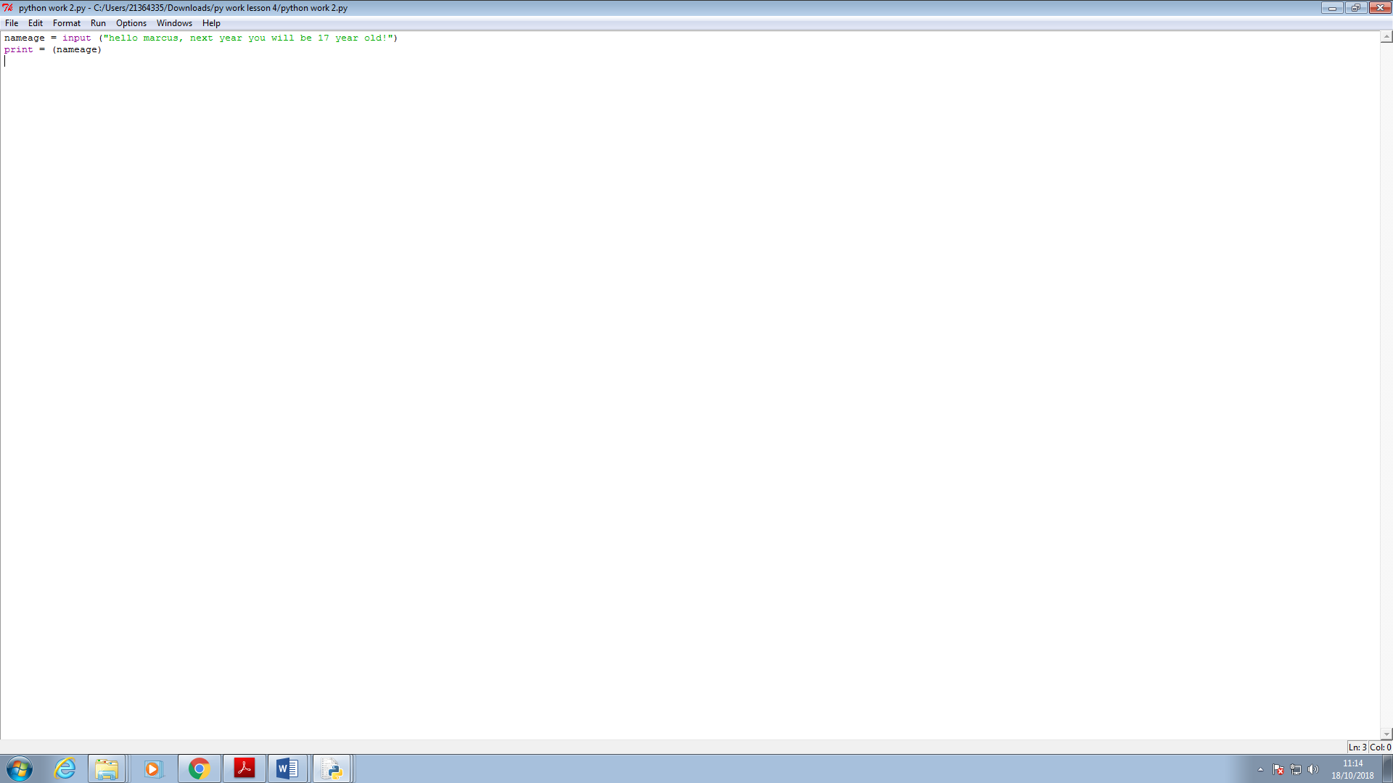

9. Given that radius is 2 and area is calculated as 12.5678, use string format

operators to print the values of the variables radius and area so that the

output looks like this:

Radius is: 2

Area is: 12.57

10. What are the values of the following expressions, assuming that p is 17 and

q is 18?

a. p // 10 + p % 10

b. p % 2 + q % 2

c. (p + q) // 2

d. (p + q) / 2.0

